INTRODUCTION TO ANALYTICS

ALY6010, WINTER 2022

Module 1 R Practice assignment

Week-1

Submitted by: Abhinav Jain

NUID: 002938209

Submitted To: Tom Breur

Date: 02/28/2022

**Module 1**

**Week 1**

**Introduction: R Practice**

Introduction:

Wine tasting is as old as the industry itself, from the 14th century onwards, a more systematic approach has gradually emerged. Professional wine tasters (such as sommeliers or retail purchasers) utilize a continually growing specialized lexicon to describe a wine's spectrum of perceived flavors, aromas, and overall qualities. Similar terminology could be used in more informal, recreational evaluations, which typically involve a far less objective method for a more general, part of personal.

In this R Practice workshop we are implementing as per the instruction performing statistical functions in R. We have used wine taste data set with 1000 observations and 14 variables. This dataset will help in providing insights about the wine_taste which has variables designation, description, taste, price, province, region_1, region_2, taster_name, tastera_twitter_handle, title, variety, winery.

Here, will show performing statistical analysis while performing command in R.

Task 1: In this task imported dataset file into R by using read.csv() which contains 1000 observations and 14 variables in “wine_data” which consists of

Task 2: Create Duplicate Dataset to fill missing value with NA

Task 3: Rename the dataset



Task 4: Drop the variables from dataset

Task 4: Structure of the dataset

Task 5: Summary the variables

Task 6: glimpse()

Task 10: Box plot()

Task 11: Plot a Bargraph:-Points for wine

**

**Task 13: ggplot()**

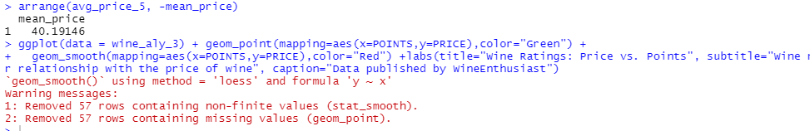

**Reference:**

[1]Create a new ggplot

<https://ggplot2.tidyverse.org/reference/ggplot.html>

[2]Exploring, cleaning, and analysing data in R - YouTube

A replay of a non-technical livestream that walked through how to explore, clean, and analyse data in R, using the 'starwars' dataset that is built into the ...

<https://www.youtube.com/watch?v=Ap1Q2fkqO_I>

[3]How To Make Frequency Table in R - Programming R Tutorials

<https://www.programmingr.com/statistics/frequency-table/>

[4]Wine tasting

<https://en.wikipedia.org/wiki/Wine_tasting#:~:text=There%20are%20five%20basic%20steps,expressiveness%2C%20complexity%2C%20and%20connectedness.>

[5]R in Action

<https://www.google.com/books/edition/R_in_Action/1TkzEAAAQBAJ?hl=en&gbpv=1&printsec=frontcover>